CURRICULUM VITAE
of

Faculty of Medicine

Benha University

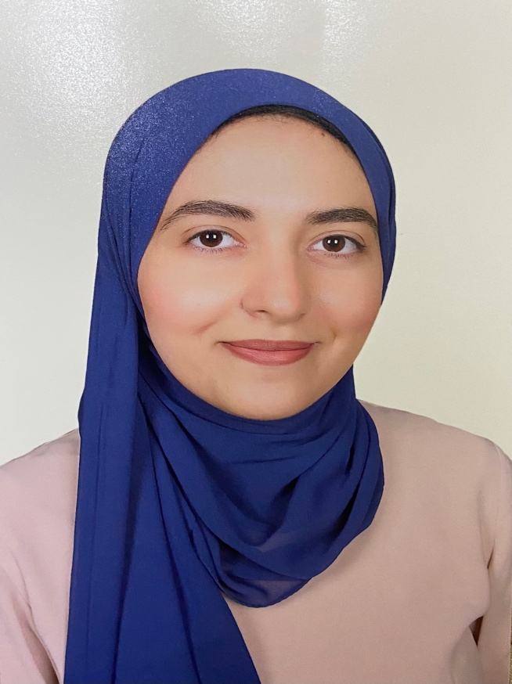

Personal photo

Personal Data
Name (Arabic) | ايمان السيد حسن محمد غالي
Name (English) | Eman El-sayed Hassan Mohamed Ghaly
Department | Forensic medicine and clinical toxicology
College | Faculty of medicine
Academic degree | Demonstrator from august 2023
Mobile | 01098526854
Home phone
work phone
Email (university) | e.hassan66999@fmed.bu.edu.eg
Alternative E mail | Emanghaly977@gmail.com
Web site

Education
Institution | Degrees obtained | Year
Benha University | Bachelor of medicine and surgery | 2021
Benha University
Benha University

General specialty | medicine and general surgery
Specific specialty | Forensic medicine and clinical toxocology

Language
Language | Reading | Speaking | Writing
Arabic | Excellent | Excellent | Excellent
English | Very good | Very good | Very good

Membership of Professional Bodies (List)

Interesting Areas of Research

MSc Supervision
Title | Year completed / in  Progress

PhD Supervision
Title | Year completed / in progress

Positions
Date From - to |  | Organization | Country | Position | Role
1 | 2023 till now | Forensic medicine and clinical toxicology | Egypt | Demonstrator | Teaching
2
3
4
5

Attended Workshops, Symposiums, and Conference
Name of Workshops, Symposiums, and Conferences | Year

- Training and Clinical Experience:
a-
b-

- Skills:

b.

- List of publications:

